Recovery College Principles
6 Principles of Recovery College

RECOVERY
Recovery is defined as a state where persons are hopeful, empowered, and feel connected to others. It is individualized, being that it is defined by each person themselves, equity-based in that resources are directed by and to those who need them most, and it is reciprocal with each person giving back what they can to help others. We believe recovery is fundamental to the work we do and believe every individual is an expert in their recovery journey.

INCLUSIVITY
lnclusivity acknowledges the diversity of ideas, people, skills, knowledge and expertise, and brings that diversity forward to a position of influence. The Recovery College draws on values of respect, equity, and trust by actively engaging people with personal experience of mental health concerns and substance use across all platforms of its mission. The aim is to have people with mental health concerns and substance use represented visibly and meaningfully. lnclusivity is an active process. It views all behaviour as episodic, meaning no one is ever excluded totally. It asks all participants to be active, meaning they are participants in their own recovery, and it provides opportunity for those effected by programs to active participants in decision making.

PEER CENTERED & PEER VALUED
The Recovery College is fundamentally Peer Centered and Peer Valued. Peer centred means that peers sit at the heart of everything we do, the fundamental question being: are peers leading and participating in an equitable manner and is all the work we do done in the best interest of peers? In order to live this principle, the Recovery College demonstrates its commitment to peer value by focusing on building the skills, capacities and knowledge of each peer, facilitator, and student.
Co-PRODUCTION & COLLABORATION
We define co-production as a process of working together wherever each stakeholder - peer, facilitator, and student
- has an equitable responsibility and opportunity to developing ideas, programs and projects for the Recovery College. Co-production aims to harmonize each stake­ holder's strengths, giving value to all voices, especially those typically excluded by entrenched power structures. In doing so, those impacted by the programs are at the centre of the work. Collaboration is integral to faithfully adhere to the co-production principle.
Collaboration is underpinned by strong bonds of trust tested through ongoing cooperation as well as transparent and shared decision making.

TRANSFORMATIONAL &
PROGRESSIVE EDUCATION
Transformational and progressive education can be understood as an approach that focuses on developing individualized solution-focused learning that helps communities shift their perspective, broadening their knowledge or skills and develop critical thinking. The Recovery College model of transformational education is cyclical; in all interactions they model positivity, which in turn impacts peers, facilitators, and students, who in turn model those behaviours in the community.
Transformational education draws on values of trust and engagement and acknowledges that being progressive means taking a fluid approach to learning; how one becomes invested in learning is an individual experience.

SEEDS COMMUNITY
The Recovery College seeds community. We believe that at the heart of all community is friendship and that peers model friendship with other peers. In doing so, peer help seed community with every interaction. Community seeding leads to greater interdependence among one another and creates more choice in the supports available for mental health and substance use, the aim being to create resilient people and resilient communities. The Recovery College is a complement to health systems by embedding friendship and care for one another in the hands of peers, facilitators, and students in an accessible and de-stigmatizing manner.

Canadian Mental Health Association
Mental health for all 39

Recovery College Competencies

CMHA Calgary has a focus of Belonging, Connectedness, and Hope. Some of the competencies for Recovery College relate to these primary areas of focus and are color-coded below.
I
I HOPE
Students gain a sense of hope that they will be successful in their own personal journey or recovery. Students can identify that even in difficult situations positive choices can be made. Students show increased self-awareness and self-esteem through their lived experience.

COLLABORATION
Students gain an understanding of interpersonal relationships that are positive, respectful and offer mutual support. Students are adaptable, willing to compromise, exchange ideas and value the contributions of others; while understanding that personal thoughts and attitudes influence their behavior and interactions. Students learn how to work with others, with lived experience and without, to achieve a common goal.
- Respect/Tolerance
- Boundaries
- Conflict Resolution

PERSONAL GROWTH & WELLBEING
Student understand the importance of self-care, emotional balance and resiliency strategies that work best for them to remain healthy. Students set learning goals and work towards them by drawing on their lived experience, strengths and interests. Students have opportunities to practice the skills they learn while in recovery college and in their broader community.
- Self-esteem
- Confidence
- Self-awareness
- Courage

SUPPORTS RECOVERY PLANNING
Students learn to take charge of their own lives and recovery journey versus taking on another person 's recovery journey. Recovery often leads people to want to make changes in their lives.
I Students self-determine their recovery plan including setting and accomplishing goals related to home,
I work, community and health.
- Recovery knowledge
I
- Recovery plan
- Boundaries

COMMUNICATION
Students learn to communicate in a manner that demonstrates a balance of self-regulation, self­ confidence with openness to the thoughts and opinions of others. Students demonstrate respect, recovery focused language, empathy and responsibility when communicating with others.
- Boundaries
- Conflict resolution
- Tolerance

41

I

I CREATIVITY AND COMMITMENT
1 Students apply concepts they have learned and identify their lived experience as a skill and asset to support their own recovery journey. Students recognize opportunities to apply ideas creatively and in new ways. They will demonstrate optimism, initiative and commitment to use what they learn to take risks and adapt to changing environments.

CRITICAL THINKING
Students learn to actively listen and reflect on their understanding of information or situations. Students self-reflect on their thinking to identify personal biases or perspectives and how that may influence their learning and behavior. They challenge assumptions behind thoughts, beliefs or actions and value honesty, fairness and open-mindedness.

PROBLEM SOLVING
Students select strategies and resources to move from what is known to what is sought. Students analyze situations, create plans of action and implement solutions to support their recovery journey. They evaluate alternatives and their consequences. Students approach challenges with creativity, flexibility and determination.

MANAGING INFORMATION
Students access, interpret, evaluate and share information from a variety of digital and non-digital sources. Students value reliability, validity and integrity of information. Students are able to take information, filter it, and relate it to their own lived experience and recovery journey.

COMMUNITY ENGAGEMENT/CAPACITY BUILDING
Students learn to actively engage and create positive connections in their community to support their recovery journey. They advocate for the dignity and well-being of individuals and caregivers with lived experience and support engagement of personal networks outside of the formal support systems.
Students value equity and diversity, and believe in their capacity to make a difference and give back to their community. Students are engaged in addressing mental health and well-being in their community.
- VolunteersNolunPeers

INCLUSIVITY/ACCEPTANCE
Students learn to accept themselves and others where they are at in their journey. They acknowledge all perspectives, life experiences and cultures (i.e. First Nations, Metis, Inuit, Francophone, Immigrants, etc.) with an openness to be inclusive of everyone.
- Stigma reduction (i.e. mental health, addiction, disabilities, etc.)
- Diversity (i.e. gender, experience, etc.)
- Cultural equity
- Tolerance

Canadian Mental Health Association
c :n ::: .r
42 Mental health for all

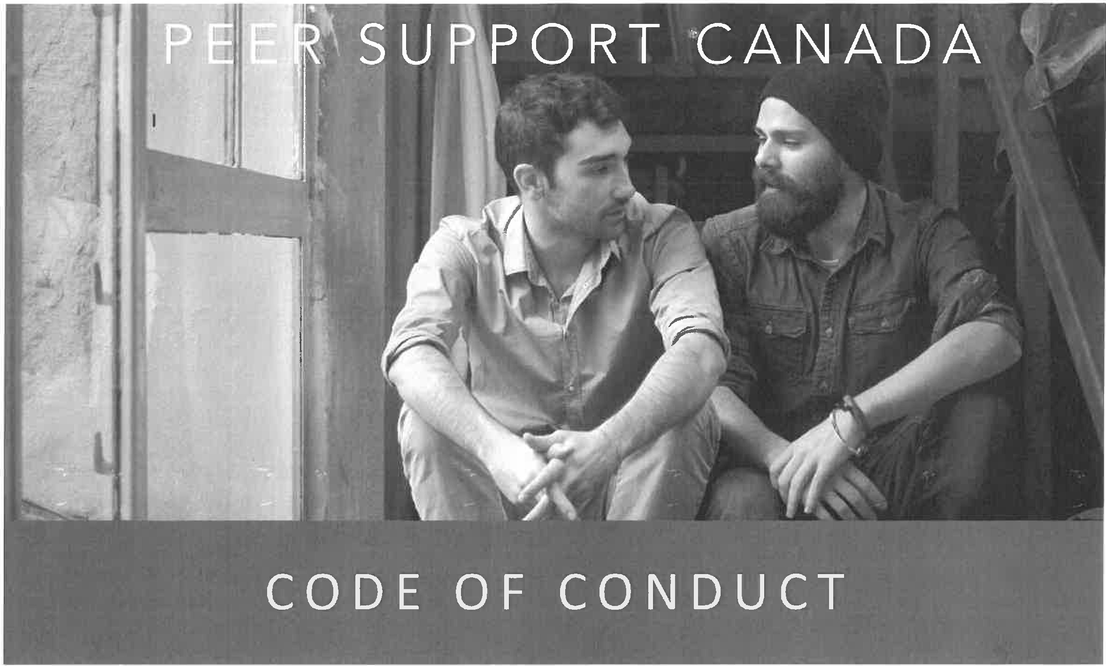

As Certified Peer Supporters we adhere to the following Code of Conduct:

I will act ethically, according to the values and principles of peer support I will treat all people with respect and dignity
I will respect human diversity and will foster non-discriminatory activities I will honour the rights, beliefs and personal values of individuals
I will behave with honesty and integrity in providing support to peers

I will respect the privacy of individuals and maintain confidentiality within the limitations of program policies and the law e.g. potential harm to self or others

I will not knowingly expose a peer to harm

I will not take advantage of the peer relationship for personal benefit, material or financial gain

I will respect the boundaries of peer support work and will not engage in romantic or sexual relationships with the peers that I support

I will not provide peer support in a manner that negatively affects the public's confidence in peer support

Peer Support Canada

